Fotos para rolagem do site

<https://www.shutterstock.com/pt/image-photo/design-studio-creativity-ideas-wood-palette-365367170?src=k-5Jf0B_2VPMM9GwTXkeFw-1-0>

<https://www.shutterstock.com/pt/image-photo/multiethnic-group-people-planning-ideas-193983560>

<https://www.shutterstock.com/pt/image-photo/business-team-brainstorming-workspace-concept-525198061?src=cpPrQtEbnHTMA5bGX67PAA-1-2>

<https://www.shutterstock.com/pt/image-photo/business-people-planning-strategy-analysis-office-368997863?src=R-9PzAqZq1rn48wluH6OoA-1-31>

<https://www.shutterstock.com/pt/image-photo/digital-marketing-media-web-design-ideas-418744291?src=trCeTj-Vg7B1n69loX1xlw-1-13>

Gerenciamento de mídias sociais

<https://www.shutterstock.com/pt/image-photo/kiev-ukraine-january-19-2017-set-566786650?src=S-C6d0WoWeMrkR9gOIvPhg-1-40>

Desenvolvimento de sites

<https://www.shutterstock.com/pt/image-photo/web-design-template-copy-space-concept-526812055?src=d5AkHf6tyYY6QVRdE7jEgw-1-3>

Vou terceirizar todos os desenvolvimentos de sites contigo. O único que tenho 100% no ar: www.nso.com.br

Se puderes “emprestar” um projeto bacana - te agradeço.

Pesquisa de mercado

<https://www.shutterstock.com/pt/image-vector/market-research-statistics-symbolized-by-population-112148744?src=b0ceQ8oLDgpl0UBQxIG8Kg-1-57>

Agência de propaganda



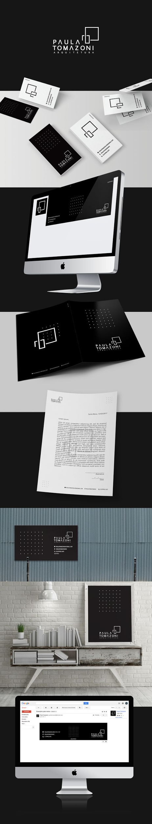

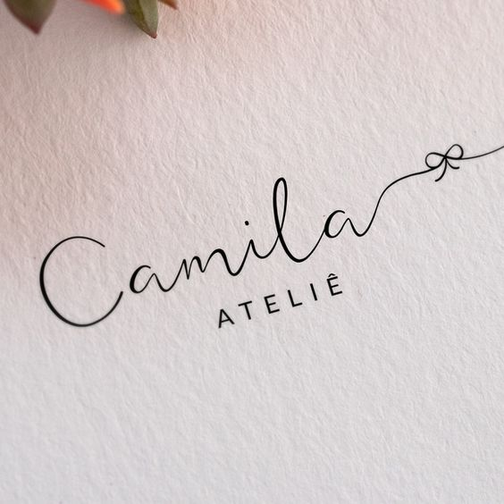







Rótulos

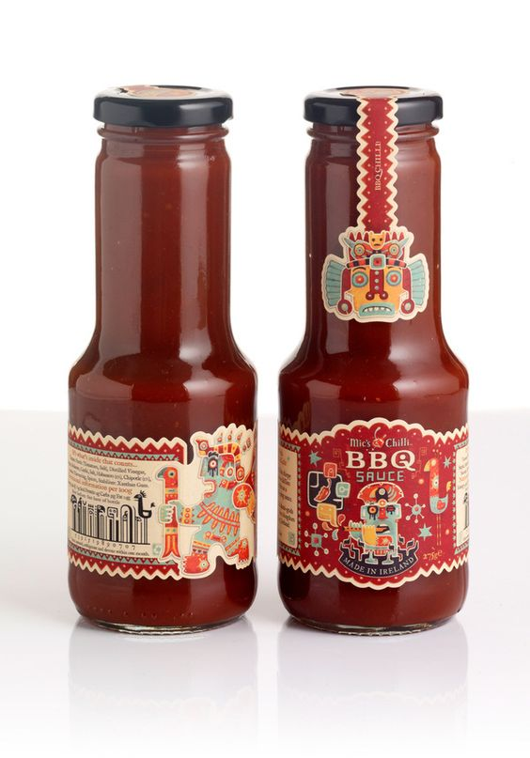

Catálogos

essa imagem é só pra ilustrar - então eu preciso que você tire a escrita em cima

